8768696: [Add Fundamentals Source for KeyCannedReports] - Tech Design for implementation process of adding source

Date Created: 03/28/2025

Last Updated: 03/31/2025

Table of Contents

Business Overview 3

Technical Design Overview 3

|  |
| --- |
| Technical Design Overview |

This research is Identify the column ‘KeyCannedReportSource’ in source server and to add the new field under the 'Canned Reports' dimension.

As part of this research,we have identified the column ‘KeyCannedReportSource’ is available in below table in server SNLDB2

Table : onlineservices.dbo.cannedreports

Table : lookup..cannedreportsource

In sql server jobs we have a job gatherUsageData_Bundle, in this job package gatherUsageData_Bundle.dtsx

From the Dataflow task data is loading into the canned reports dimension table olap.dbo.CannedReports

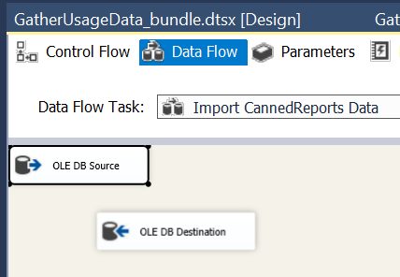

Below four columns are loading from the tables lookup.dbo.cannedreporttype and onlineservices.dbo.cannedreports

into olap table olap.dbo.CannedReports

keycannedreport,

CannedReport,

KeyCannedReportType,

CannedReportType

Below is the source query which is using in the data flow task to load the data Into olap table.

select cr.keycannedreports, try_convert(varchar(255), (rtrim(cr.cannedreport) + ' (' + try_convert(varchar(25), cr.keycannedreports) + ')')) CannedReport,

case when crt.keycannedreporttype is null then -2 else crt.keycannedreporttype end KeyCannedReportType,

case when crt.keycannedreporttype is null then 'Unclassified' else rtrim(crt.cannedreporttypes) end CannedReportType

from onlineservices.dbo.cannedreports cr

left join lookup.dbo.cannedreporttype crt on cr.keycannedreporttype=crt.keycannedreporttype

union

select 0, 'None', -1, 'None'

Here, by **modifying the ETL** we can add the new field ‘KeyCannedReportSource’ in the source query to load into olap table.

And also we have to **create a table dbo.CannedReportSource** in OLAP and need to pull the table from source lookup..CannedReportSource to OLAP table

after that, altering the table by adding the new field to the olap.dbo.CannedReports.

ALTER table cannedReports add [KeyCannedReportSource] [tinyint] NULL

And CannedReports table is using in below procedure we have to alter the below procedures if required.

ApplyForeignKeys

CleanUsageData_PS

CleanUsageData

CheckForeignKeys

So , once the data is available with the new field in table olap.dbo.CannedReports,next is to add the new attribute in the cube dimension.

configure the new attribute properties in the cube dimension, process and deploy the changes in the dev cube to reflect the new field under the 'Canned Reports' dimension.